CTA Standard Template

Doc. Number: CTA-XXXX Date: MM/DD/YYYY

Document Title

For further information:
R# WG# Chair: Name, Company
Phone: Email:

CTA Staff: Name, Phone, Email

Development History:
mm/dd/yyyy: Draft v1 distributed.

Notice:
This draft standard [or bulletin] is copyrighted by the Consumer Technology Association™ (CTA). No distribution outside of the responsible formulating group, or outside of a member company of the responsible formulating group, is permitted without the prior written permission of CTA staff. Federal copyright law prohibits unauthorized reproduction of this document by any means. Any questions regarding this paragraph shall be directed to CTA staff.
Standards, Bulletins and other technical publications are adopted by the Consumer Technology Association in accordance with the American National Standards Institute (ANSI) patent policy. By such action, the Consumer Technology Association does not assume any liability to any patent owner, nor does it assume any obligation whatever to parties adopting the Standard, Bulletin or other technical publication.
Patent Disclosure Request:
In accordance with clause 15 of EP-23, if the committee or subcommittee receives notice that a proposed standard may require the use of a patented invention, the patent holder shall provide the IP proffer to a CTA Technology & Standards staff representative, prior to meeting vote or ballot.
Requirements in CTA standards that are known to call for use of a patented item or process may not be knowingly considered by committees and subcommittees unless the responsible chair and CTA Technology & Standards staff have received a statement from the patent applicant or holder indicating compliance with the CTA intellectual property rights policy by stating one of the following:
- a license shall be made available without charge to applicants desiring to use the patent for the purpose of implementing the standard(s) under reasonable terms and conditions that are demonstrably free of any unfair discrimination, or
- a license shall be made available with charge to applicants under reasonable terms and conditions that are demonstrably free of any unfair discrimination.

The statement from the patent holder should be provided in the IP Proffer form (available at https://standards.cta.tech/ under the Rules tab). CTA will not accept statements which are conditional or which reveal the terms of licensing.
For further information, please contact the responsible CTA staff person at 703-907-____ or _______@cta.tech.
REMOVE THIS PAGE PRIOR TO PUBLISHING

Forward
This standard was developed by the Consumer Technology Association’s insert committee or subcommittee name and title.

(This page intentionally left blank.)

Table of Contents
[All tables inserted by CTA staff at publication. A temporary ToC, figures list, or tables list may be inserted if helpful during draft development.]

Figures

Tables

(This page intentionally left blank.)

Title of Document

Scope
Scope of standard.

Revision History [if needed]
  - CTA-XXXX
[If the Scope of the current published version has been modified (i.e. the revision has an expanded scope), note that here.]
[Include any significant requirements that have been removed from the revised version, and any significant deletions.]
  - CTA-XXXX-A
[Include in this section the purpose for the revision (if not already mentioned in the updated scope), any newly added requirement and significant updates/modifications.]

References

Normative References
The following standards contain provisions that, through reference in this text, constitute normative provisions of this standard. At the time of publication, the editions indicated were valid. All standards are subject to revision, and parties to agreements based on this standard are encouraged to investigate the possibility of applying the most recent editions of the standards listed here.

Normative Reference List
- CTA-2034-A, Standard Method of Measurement for In-Home Loudspeakers, February 2015, https://cta.tech/standards.
- Gander, Mark. “Ground Plane Acoustic Measurements of Loudspeaker Systems.” Journal of the Audio Engineering Society, vol. 30, no. 10 (1982): 723.

Informative References
The following references contain provisions that, through reference in this text, constitute informative provisions of this standard. At the time of publication, the edition indicated was valid. All standards are subject to revision, and parties to agreements based on this standard are encouraged to investigate the possibility of applying the most recent edition of the standard indicated below.

Informative Reference List
- Designation, Title of informative reference 1.

Compliance Notation
[Note: The text below is for standards. For bulletins or other non-normative documents, remove SHALL and SHALL NOT from the list.]
CTA defines the following compliance terms for use in its documents:
shall | This word indicates specific provisions that are to be followed strictly (no deviation is permitted).
shall not | This phrase indicates specific provisions that are absolutely prohibited.
should | This word indicates that a certain course of action is preferred but not necessarily required.
should not | This phrase means a certain possibility or course of action is undesirable but not prohibited.
may | This phrase indicates that a certain course of action is optional.

Definitions, Symbols and Abbreviations

Definitions
Term 1: Definition of term 1.
Term 2: Definition of term 2.

Symbols and Abbreviations
ABC Expansion of symbol/abbreviation ABC
DEF Expansion of symbol/abbreviation DEF

SIXTH Section Title
[Editors working in a document that makes use of Word bookmarks and fields should have two options set so that the editor can see where automatically-updating text is in the document. The two options are “Show bookmarks” and “Field shading:Always,” and are shown below in Figure 1.]
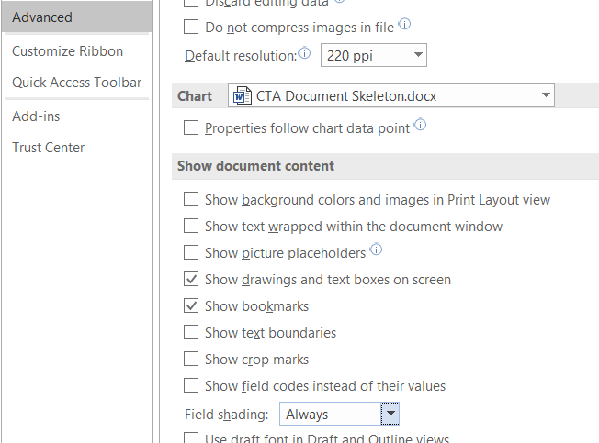
Figure 1: Microsoft Word Options

First Subsection under Sixth Section Title
Text starts here…… as described in Table 1 … shown in Figure 2.
Table 1: Title
Frequency (Hz) | Relative level (dB) | Tolerance (dB) |  | Frequency (Hz) | Relative level (dB) | Tolerance (dB)
5 | - 24.1 | ± 2.0 |  | 400 | 0 | ± 0.5
6.3 | - 20.1 | ± 2.0 |  | 500 | 0 | ± 0.5
8 | - 16.0 | ± 2.0 |  | 630 | - 0.1 | ± 0.5
10 | - 12.2 | ± 2.0 |  | 800 | - 0.1 | ± 0.5
12.5 | - 8.8 | ± 1.0 |  | 1,000 | - 0.2 | ± 0.6
16 | - 5.4 | ± 1.0 |  | 1,250 | - 0.4 | ± 0.7
20 | - 3.0 | ± 1.0 |  | 1,600 | - 0.6 | ± 0.8

This is text below Table 1. The drawing below shows a blue line for IEC 60258; there are many lines in Figure 1.
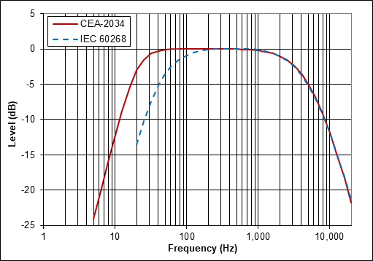
Figure 2: Title
This is text immediately following a figure.

Second Subsection under Sixth Section Title
Text starts here……

First Subsection under Second Subsection of Sixth Section Title
Text starts here…… specified in Section 7.1.
Text starts here…… shown in Figure 2.

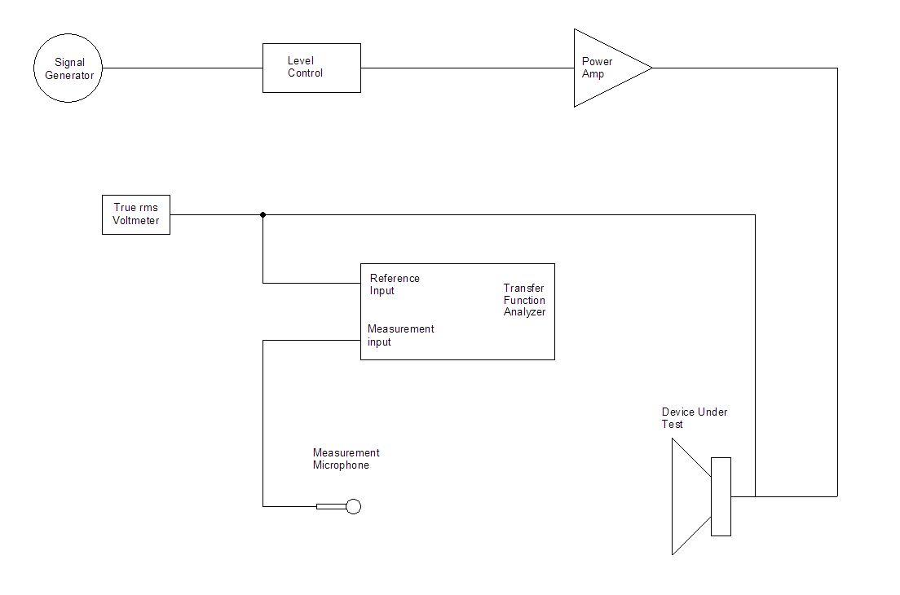
Figure 3: Title

Annex A

Informative [or Normative]
- Section Title
Text starts here……

Table A.1: Title
Tone Burst Center Frequency (Hz) | Maximum SPL | CTA-2010 Rating
20 |  | Average of 20, 25 and 31.5 Hz values
25
31.5
40 |  | Average of 40, 50 and 63 Hz values
50
63

- First Subsection of Annex A
Text here…
    - First Third-level Subsection under Annex
Text here…

